**Electric Motors**

A production facility manufactures small electric motors for use in an electrical **appliance** (either a fan, a hair dryer, a screwdriver or a food mixer) and production runs are in one of three **shifts** - morning, evening or night and on one of two production lines X or Y. Every motor is tested, and the percentage of defective is recorded, separately for **line X** and **line Y**. The process manager is interested in investigating if certain conditions in the manufacturing environment may be contributing to the defective rate. In particular, ambient **temperature** (oC) and **noise** (dB), which are recorded for each run – as is a record of whether or not each line crew opted to have a **radio** on while they work on that shift.

1. Are the defective rates for the two production lines operating in the same shift different?
2. How, if at all, does defective rate on line X vary between shifts?
3. Does the ambient temperature have an impact on the line X defective rate?
4. What effect does having a radio on have on the line X defective rate?
5. Is the radio more likely to be on one some shifts compared to others?
6. Is there evidence that the line X defective rate is related to ambient noise?
7. Do motors made on line X for one particular appliance tend to be more prone to defects that others?
8. Are motors made for different appliance made with similar frequencies on all three shifts?

*Solution*

|  |  |  |  |  |  |
| --- | --- | --- | --- | --- | --- |
| Name | Davin Barron | ID | 20102008 | Programme | Applied |

Q1 Are the defective rates for the two production lines operating in the same shift different?

A scatter plot of production line Y against line X is shown opposite. There is a real indication that the data tends to follow a straight-line trend.

An inferential test revealed that the correlation between line X and line Y yields a p value of 2.2e-16. As p < 0.05 we can report that there is a statistically significant difference between the two lines, which is consistent with the plot.

Thus, based on the analysis of these data, we have evidence that the defective rates for the two production lines operating in the same shift are similar.

A Henze-Zirkler test was performed to check if the defective rates for both line X and line Y follow a joint normal distribution. This was found to be satisfactory.

Q2 How, if at all, does defective rate on line X vary between shifts?

A boxplot is shown (below left) for the defective rate on line X between different shifts. The plot indicates that the defective rates are quite similar regardless of the shift.

Summary statistics for the sampled data is shown (below right).

|  |  |  |  |
| --- | --- | --- | --- |
| Shift | Mean | Standard Deviation | Sample Size |
| Morning | 3.38 | 0.84 | 40 |
| Evening | 3.21 | 0.87 | 35 |
| Night | 3.47 | 0.94 | 45 |

A suitable statistical test to check if the defective rate on line X is likely to differ between production shifts is the ANOVA test.

The output from R for this test yields a p value of 0.448, we can report that there is not a statistically significant difference from zero. Thus, based on the analysis, we have no evidence to suggest that the defective rate on line X varies between shifts.

A Levene’s test was performed to check equal variances across different shifts for the defective rate of line X. This was found to be satisfactory.

Q3 Does the ambient temperature have an impact on the line X defective rate?

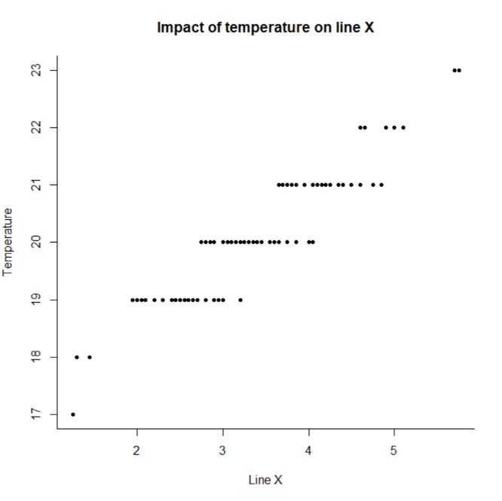A scatter plot of the ambient temperature against line X is shown opposite. There is a real indication that the data tends to follow a straight-line trend.

An inferential test revealed that the correlation between line X and ambient temperature yields a p value of 2.2e-16. As p < 0.05 we can report that there is a statistically significant difference between line X and the temperature, which is consistent with the plot.

Thus, based on the analysis of these data, we have evidence that the ambient temperature does have an impact on the line X defective rate.

Q4 What effect does having a radio on have on the line X defective rate?

A boxplot is shown (below left) for radio’s that are and are not turned on. The plot indicates that the defective rates are quite similar regardless of state of the radio.

Summary statistics for the sampled data is shown (below right)

|  |  |  |  |
| --- | --- | --- | --- |
| Radio | Mean | Standard Deviation | Sample Size |
| On | 3.44 | 0.90 | 65 |
| Off | 3.38 | 0.89 | 50 |

A suitable statistical test to check if the defective rate on the production of motors on line X is effected by the state of the radio is the independent samples t test.

The output from R for this test yields a p value of 0.7382, we can report that this was not statistically significant different from zero. Thus, based on the analysis, we have no evidence to suggest that the defective rate on line X is effected by the radio.

The t test requires that checks be made that whether or not the radio is turned on follow what is called a normal distribution. This was found (using the Shapiro-Wilkes test) to be satisfactory.

Q5 Is the radio more likely to be on one some shifts compared to others?

A barplot is shown opposite for radio’s that are and are not turned on for different shifts. The plot indicates that the likelihood of a radio being on one during a shift is nearly equal for each shift.

A suitable statistical test to check if the radio is more likely to be on one on a shift is the chi-squared test.

The output from R for this test yields a p value of 0.8296, we can report that this was not statistically significant different from zero. Thus, based on the analysis, we have no evidence to suggest that the radio is more likely to be on one some shifts compared to others.

Q6 Is there evidence that the line X defective rate is related to ambient noise?

A scatter plot of line X against the ambient noise is shown opposite. There is no real indication that the data tends to follow a straight-line trend.

An inferential test revealed that the correlation between the defective rate on line X and the ambient noise was 0.7764 but this was not statistically significantly different from zero, which is consistent with the plot

Thus, based on the analysis of these data, we have no evidence that the ambient noise is related to the defective rate on line X.

Q7 Do motors made on line X for one particular appliance tend to be more prone to defects that others?

A boxplot is shown (below left) for the defective rate on line X between different appliances. The plot indicates that there is a bit of variation in the defective rates between the appliances. For example, we can see that a fan(1) has the highest defective rate out of the bunch, meanwhile, a hairdryer(2) is significantly lower.

Summary statistics for the sampled data is shown (below right).

|  |  |  |  |
| --- | --- | --- | --- |
| Shift | Mean | Standard Deviation | Sample Size |
| Fan | 3.96 | 0.67 | 28 |
| Hairdryer | 2.65 | 0.69 | 34 |
| Screwdriver | 3.76 | 0.80 | 28 |
| Food Mixer | 3.23 | 0.70 | 29 |

A suitable statistical test to check if the motors made on line X for one particular appliance is more prone to defects than others is the ANOVA test.

The output from R for this test yields a p value of 1.62e-10. As p < 0.05, we can report that there is a statistically significant difference for the defective rate between the different appliances. Thus, based on the analysis, we have evidence to suggest that motors made for one particular appliance tend to be more prone to defects than others.

Q8 Are motors made for different appliance made with similar frequencies on all three shifts?

A barplot is shown opposite for motors that are made for different appliances on all three shifts. The plot indicates that the motors made on different appliances are made with varying frequences on all three shifts.

A suitable statistical test to check if the motors made for appliances made with similar frequencies on all three shifts is the chi-squared test.

The output from R for this test yields a p value of 0.01959. As p < 0.05, we can report there is a statistically significant difference in the frequencies of appliances made across the different shifts. This means that the type of appliance being made is not independent of the shift. In other words, the frequencies of appliances made are not similar across all three shifts. Thus, based on the analysis, we have no evidence to suggest that motors made for different appliance are made with similar frequencies on all three shifts. But rather they are made in varying frequencies.

*R Script*

############################################################

# Statistics Assignment (Stats and Probability)

#

# Davin Barron / ID: 20102008 / Programme: Applied

#

# R commands to address the questions pertaining to the

# production of small electric motors.

############################################################

# Load the data from the clipboard

production = read.table("clipboard", header=T)

head(production)

names(production)

attach(production)

############################################################

#

# Q1: Are the defective rates for the two production lines operating in the same shift different?

#

# correalation

plot(line_y~line_x, xlab="Line X", ylab="Line Y", pch=20, bty="L", main="Defective rates for two lines")

cor.test(line_y, line_x)

# p < 0.05

tmp = !is.na(line_y) & !is.na(line_x)

HZ.test(data.frame(line_y[tmp], line_x[tmp]))

# joint normal ok

#

# Q2: How, if at all, does defective rate on line X vary between shifts?

#

# ANOVA

boxplot(line_x ~ as.factor(shift), main="Defective Rate on Line X by Shift", xlab="Shift", ylab="Defective Rate")

tapply(line_x, shift, mean, na.rm=T)

tapply(line_x, shift, sd, na.rm=T)

tapply(line_x, shift, length)

summary(aov(line_x~as.factor(shift)))

levene.test(shift, line_x)

#

# Q3: Does the ambient temperature have an impact on the line X defective rate?

#

plot(temperature~line_x, xlab="Line X", ylab="Temperature", pch=20, bty="L", main="Impact of temperature on line X")

cor.test(temperature, line_x)

# p < 0.05

#

# Q4: What effect does having a radio on have on the line X defective rate?

#

boxplot(line_x~radio, horizontal =TRUE, xlab="Line X", ylab="Radio", main="Radio effect on line X")

# Summary stats

tapply(line_x, radio, mean, na.rm=T)

tapply(line_x, radio, sd, na.rm=T)

tapply(line_x, radio, length)

# test

t.test(line_x~radio)

# checking normality

shapiro.test(line_x[radio == '1'])

shapiro.test(line_x[radio == '2'])

#

# Q5: Is the radio more likely to be on one some shifts compared to others?

#

plot(as.factor(radio), as.factor(shift), main="Radio during shift", xlab="Radio", ylab="Shift")

chisq.test(as.factor(radio), as.factor(shift))

#

# Q6: Is there evidence that the line X defective rate is related to ambient noise?

#

plot(line_x~noise, xlab="Noise", ylab="Line X", pch=20, bty="L", main="Line X related to ambient noise")

cor.test(line_x, noise)

#

# Q7: Do motors made on line X for one particular appliance tend to be more prone to defects than others?

#

boxplot(line_x ~ as.factor(appliance), main="Defective Rate on Line X by Appliance", xlab="Appliance", ylab="Defective Rate")

tapply(line_x, appliance, mean, na.rm=T)

tapply(line_x, appliance, sd, na.rm=T)

tapply(line_x, appliance, length)

summary(aov(line_x~as.factor(appliance)))

levene.test(appliance, line_x)

#

# Q8: Are motors made for different appliance made with similar frequencies on all three shifts?

#

plot(as.factor(appliance), as.factor(shift), main="Applicances made on different shift", xlab="Appliance", ylab="Shift")

chisq.test(as.factor(appliance), as.factor(shift))